Adaptations

Summary
Organisms are well adapted to survive in their normal environment. Population size depends on a variety of factors including competition, predation, disease and human influences. Changes in the environment may affect the distribution and behaviour of organisms (see ‘Environmental change’ topic)

Survival
- To survive, organisms require a supply of materials from their surroundings and from the other living organisms there.
- Organisms live, grow and reproduce in places where, and at times when, conditions are suitable.

Competition (see additional notes from Ambassadors session for more details)
Animals compete for:
- Mates
- Food
- Territory

Plants compete for:
- Space
- Light
- Water
- Nutrients from the soil

Adaptation
- Organisms have features (adaptations) which enable them to survive in the conditions in which they normally live
- The organisms that are best adapted to make use of their resources in a habitat are more likely to survive and increase in numbers
- Organisms might be adapted, for example:
  - To be able to obtain a certain food better
  - To make it more difficult for predators to catch them
  - To survive in extreme climates, eg arctic and deserts

Extreme adaptations
- Extremophiles are organisms that live in extreme environments
- Some may be tolerant to high levels of salt (halophiles), high temperatures (thermophiles) or high pressures (barophiles)

Extreme animals
- Animals may be adapted for survival in dry and arctic environments by means of:
  - Changes in surface area
  - Thickness of insulating coat
  - Amount of body fat
  - Camouflage
- Examples:
  - Camel
    - The camel can go without food and water for 3-4 days
    - Fat stored in their humps provides long-term food reserves, and a supply of metabolic water
    - The fat is not distributed around the body: this reduces insulation, allowing more heat loss
    - They are tall and thing, increasing their surface area:volume ratio, increasing loss of heat by radiation
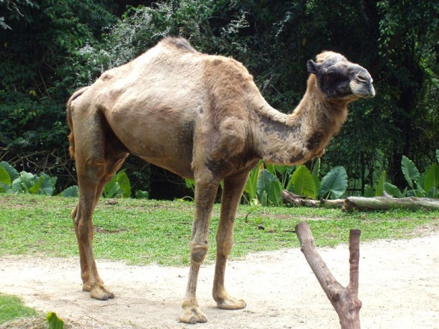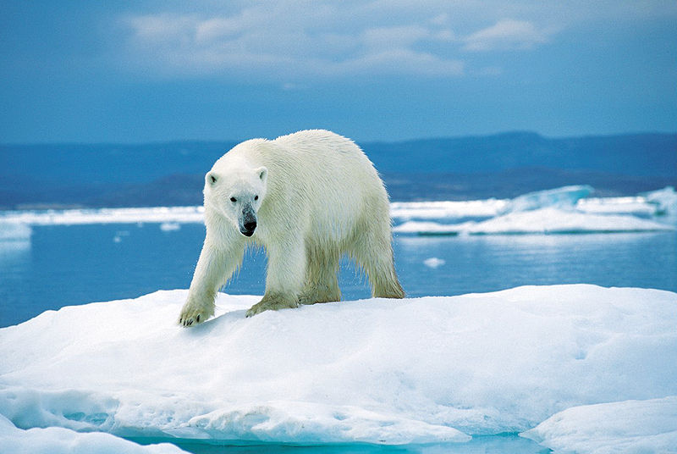

- Polar bear
  - Has thick fur and fat beneath its skin to insulate it
  - Their large, furry feet help to distribute their weight as they walk on thin ice
  - They are white which camouflages them against the snow. This helps them to hunt (remember, polar bears don’t have predators so they don’t need to change colour in the summer)
  - They are compact in shape, reducing their surface area:volume ratio. This reduces heat loss by radiation

Extreme plants
- Plants may be adapted to survive in dry environments by means of:
  - Changes in surface area, particularly of the leaves (eg, cacti)
  - Water-storage tissues (succulents like cacti and moneyplants)
  - Extensive root systems
- Desert plants
  - Eg, the cactus, requires very little water to survive
  - Leaves are spines
  - Spines guard against most browsing herbivorous animals
  - Spines also reduce the surface area, reducing water loss by evaporation
  - A thick waxy cuticle surrounds the plant to reduce evaporation
  - Fewer stomata reduces water loss
  - Roots tend to spread sideways to catch rain water
- Arctic plants
  - Many of the plants are small, growing close to the ground and very close together to avoid the wine and conserve heat
  - Some possess a light, fuzzy covering to insulate the buds so they can grow
  - Many are dark in colour (blues and purples) to absorb heat from the sun even in winter months
  - Because of the cold and short growing seasons, arctic plants grow very slowly
  - Some grow for 10 years before they produce any buds for reproduction

Microorganisms
- Slime capsule around some bacterial cells sticks them to surfaces and prevents them drying out
- Some have the ability to form spores to survive when conditions are harsh
- Some microorganisms have flagella which enable to them move around quickly
- Bacteria undergo rapid reproduction when conditions are favourable
- Some bacteria can survive extreme conditions (extremophiles are often bacteria)

